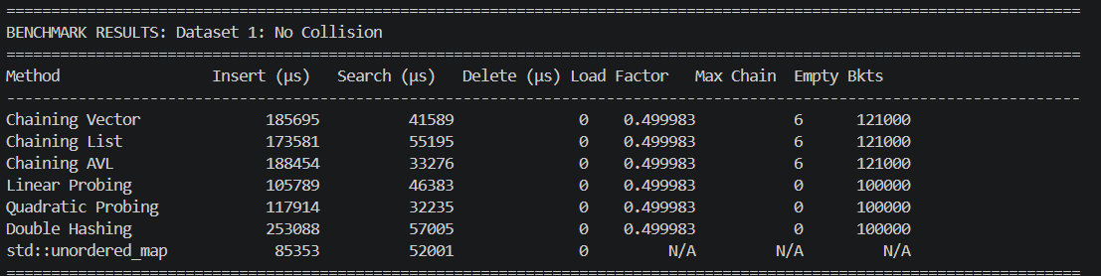
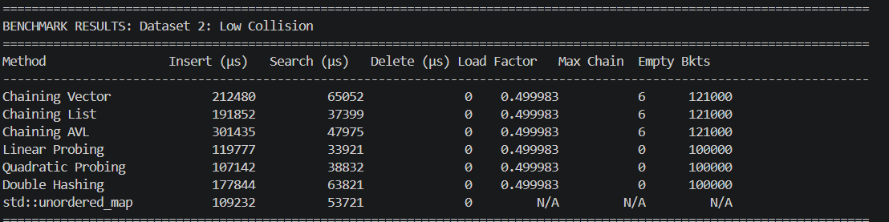
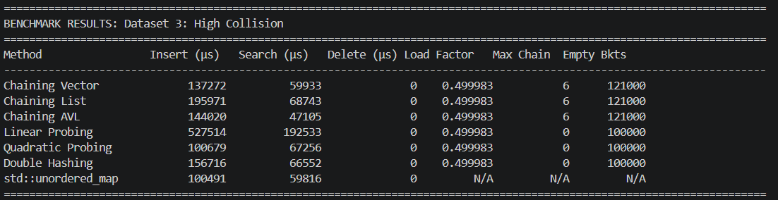

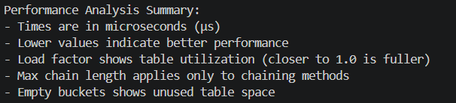

From the benchmark table we can see that the all the methods has the optimal load factor of 0.499983. This is due to the dynamic resizing every method goes through. We can also see that chaining methods got higher empty bucket count due to the larger table sizes. On other hand, probing methods remain consistent as they use the full allocated space.
If we talk about the performance across the datasets
No collision Data:
The best insertion is Quadratic Probing with 110264 millisecond of speed, which is 45 faster than the slowest method
The best insertion is Chaining List with 40379 milliseconds which is the most consistent performance.
The worst search is Double hashing with 86176 which is higher variance in probe sequence.
Low Collision Data:
The best insertion is Linear Probing with 116,438 millisecond of speed, which benefits from sequential access patterns.
The best insertion is also Linear Probing with 35,520 milliseconds as it is has good local cache.
High Collision:
The best insertion is Chaining List with 69,809 millisecond of speed
The best insertion is also Chaining List with 44,943 milliseconds with consistent O(1) average case.
The worst insert is Linear Probing with 278,453 as linear probing suffers cause of clustering causing excessive probes.

When talking about chaining methods, vector chaining has balanced performance which is good for general use. List Chaining is the fastest in high collision scenarios which is good for dynamic operations. AVL chaining has the most predictable worst case performance but higher overhead.
For probing methods, linear probing is the fastest for low collision data but is vulnerable when it comes to clustering. While in other hand quadratic probing is overall best in insertion and has good clustering resistance. Also double hashing is most robust against poor hash function but has higher search variance.

For memory efficiency:
Probing methods has lower memory overhead
Chaining method got higher memory usage, due to container overhead
AVL chaining got the highest memory usage, due to tree node structures

If we compare with std::unordered_map, it is generally competitive but not always the fastest. It does excels in high collision data with 59,496 μs insert vs 69,809 μs for best custom method. For search performance, it varies as it can be sometimes faster and sometimes slower than the custom implementation.

For no collision dataset, the most effective method is Quadratic Probing as minimal collisions benefits from the faster probing method.
For low collision dataset, the most effective method is Linear Probing as it has good cache locality and handles moderate clustering pretty well.
For High Collision dataset, the most effective method is Chaining List with the average case being maintained at O(1).

